Walker Thompson

Design Document

* 1. Context Viewpoint

The Student Assignment Scheduler project aims to use the basic information of a user’s assignment and automatically determines the approximate time the assignment will take the user to complete and the best available time for the user to complete this assignment. The user is required to input only the name, number of problems (i.e. number of pages to read, questions to answer, or words to write), and deadline of the assignment to ensure each student is only spending the appropriate amount of time and has the time available for each assignment. This application also features an assignment timer that tracks the actual time a user takes for an assignment to improve the time estimation process. The user’s Goggle Calendar functions as the source of the user’s events that this application will schedule each assignment around to avoid time conflicts. The information from the calendar is also stored locally and presented to the user as a list of events for any given day so that an online connection is not require for the application to properly function as well as to allow a user to interact or edit each event from their phone that then syncs with the google calendar with a connection is available.

* + 1. Design concerns

Possible design concerns pertaining to overall effectiveness are apparent because of the lack of testing of the application core concept of automated scheduling. There is also little outside application that would be comparable to this project that could justify some of the design choices. This project must prove to its user’s that the automated features of the application are more beneficial to the user then harmful, and without proper evidence of this to present to potential user’s, the application will have to show each user the value of this application through hands on experience until proper testing can be carried out. This issue also leads to concerns surrounding the amount of user interference possible if they cannot understand why a certain time was chosen to schedule and assignment and leading a user to lose trust in the algorithm or the application. Another design concern may arise with the use of the assignment timer as if a user needs to stop working on an assignment or accidently stops the timer then the application with record this time and incorrectly adjust the time estimation of future assignments. This issue could also occur with the ability to provide the application additional information about their preferences and settings, such as reading speed or how many breaks they prefer, that if used incorrectly can negatively impact the applications effectiveness for a user.

* + 1. Design elements

There are two primary external actors for this project. Those being the user and their respective google calendars that the application pulls a user’s schedule as well was pushes new event to the calendar. The major application process starts with the user signing into the application and linking their google calendar from the interface on the mobile device. Each event on the calendar is stored on a local database with all its relevant information. The user is then prompted to enter one of their assignments through a separate android activity page with three text fields for the name, number of task, and deadline of the assignment. This information in addition to the speed of the user pertaining to the respective assignment type is used to calculate the estimated time it will take the user to complete the assignment. Then this estimated time is compared to the available time blocks that the application finds using the locally stored calendar and the best suitable time block is selected. This event is then added to the local database and visible and intractable to the user, as well as being pushed to the goggle calendar. When it comes time for a user to begin working on an assignment, the application sends a notification to the user’s phone that when clicked on will take the user to the assignment timer already set up for the events estimated time. The user will be allowed to view their progress over time based on their performance of each type of assignment.

1.1.3 Example Languages

**Use Case Diagram (figure 1)**

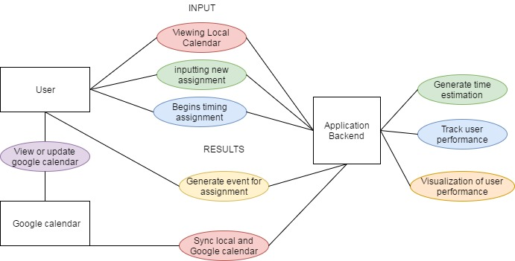

* 1. Composition viewpoint
     1. Design concerns

One of the concerns involving the assurance of this projects design model’s effectiveness is the chance that the user inputs invalid information about an assignment and cause issues for the application when creating this event. If a user were to input an invalid assignment type or does not use numeric values for the number of task, then several subordinate processes that interact with this information. This would cause large miscalculations from the applications algorithms and interfere with a user being able to complete an assignment in a timely fashion. Another concern is in the extreme case that the application can find no suitable time for an assignment given the user’s schedule before its deadline. With the automation of the application handling most of the decisions, it will be difficult to inform the user of what they may need to change for their assignment submission to be scheduled properly.

* + 1. Design elements

This project design can be organized into five major components that produce the functional model. The first part is the application interface where all the software is located as well as point for the user to interact and view the application. The layout of this application is to have one main activity with a list of the user’s current daily schedule and 3 other buttons that lead to the other activities. These other activities are “create event” where the information about an assignment is entered in text fields, “assignment timer” where the performance of the user is tracked, and “Preferences/settings” where the user can interact and customize the application to improve efficiency. The second component is the assignment time estimation process. This process takes the input from the user creating a new event and calculates the estimated time for that assignment by utilizing the number of task given, the complexity of each task that is predefined from our research, and the speed of the user in completing a single task. This produces a time for the automated scheduler, the third component, to find the next available time block that is larger than the estimated time of the assignment. This component utilizes the Google Calendar API for java to access a user’s calendar and search for the available time block. The forth component is the local database structure that uses the aforementioned Google API to retrieve a user’s events and parse out key details from the Date Time structure used by Google. The final component is the assignment timer that ensures a user is informed of how fast their completed the assignment and records this information to be used to adapt the time estimation algorithm.

* + 1. Example languages

**UML component diagram (figure 3)**

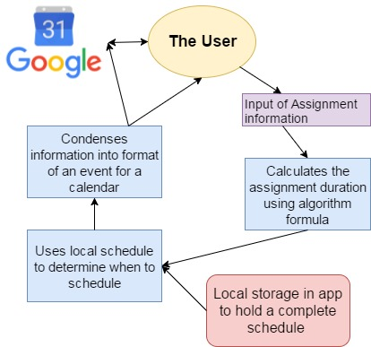

* 1. Logical viewpoint
     1. Design Concerns

In this applications implementation of Google Calendar libraries necessary in retrieving a user’s information, much of the overall format as well as how the application reads Google’s unique DateTime object that carries all an event’s information was needed to fit Google’s strict guidelines to function. This raises concerns of if these changes will affect the applications access to the google calendar across the many varieties of Android devices.

1.3.2 Design elements and Example languages

1.3.2 Design elements and Example languages

